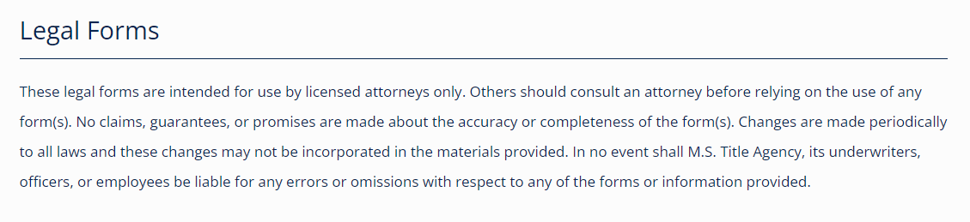
These legal forms are intended for use by licensed attorneys only. Others should consult an attorney before relying on the use of any form(s). No claims, guarantees, or promises are made about the accuracy or completeness of the form(s). Changes are made periodically to all laws and these changes may not be incorporated in the materials provided. In no event shall M.S. Title Agency, its underwriters, officers, or employees be liable for any errors or omissions with respect to any of the forms or information provided.

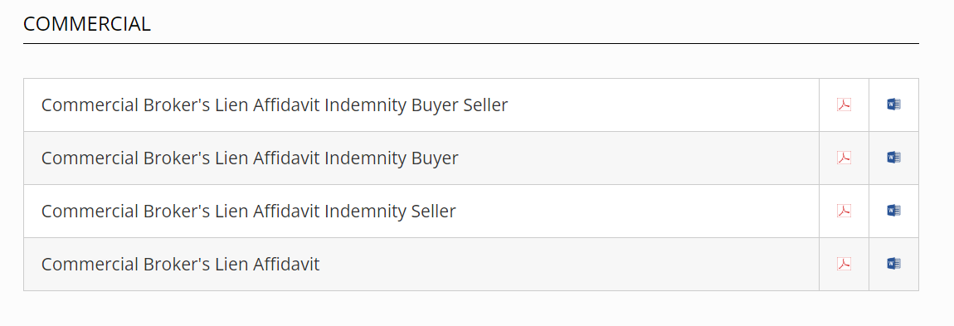
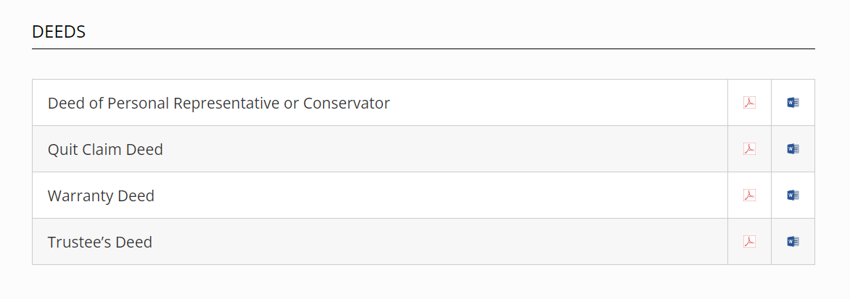
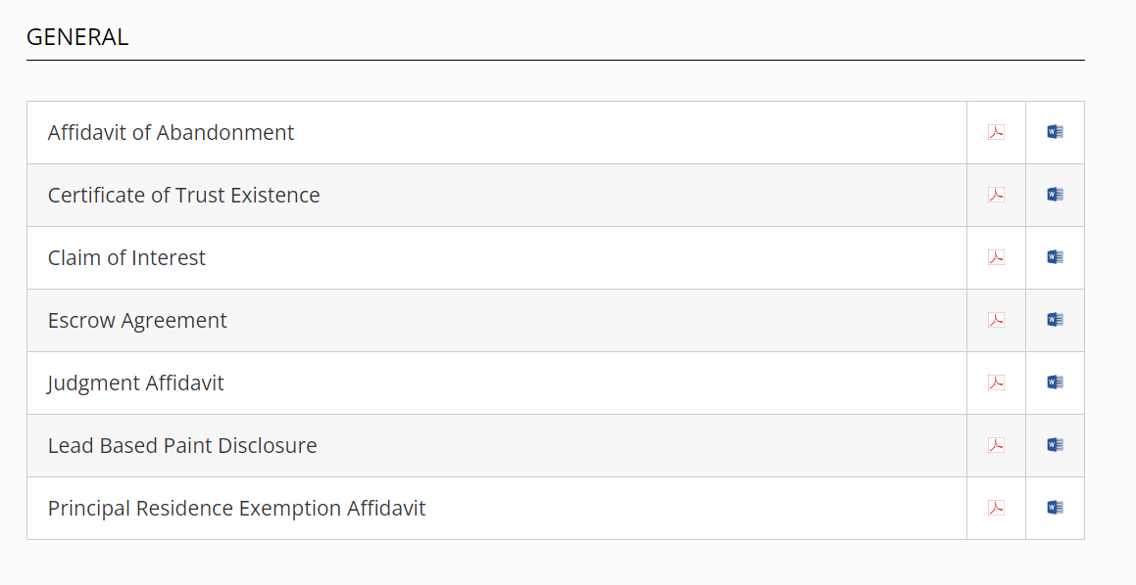

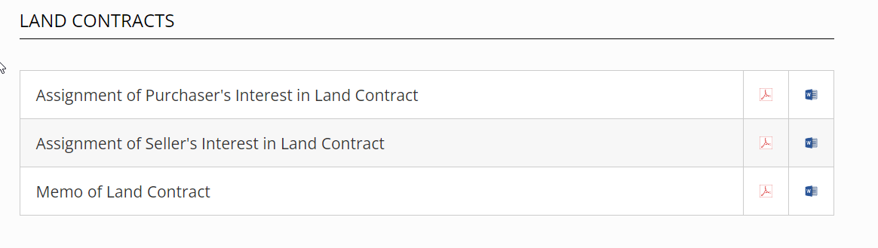
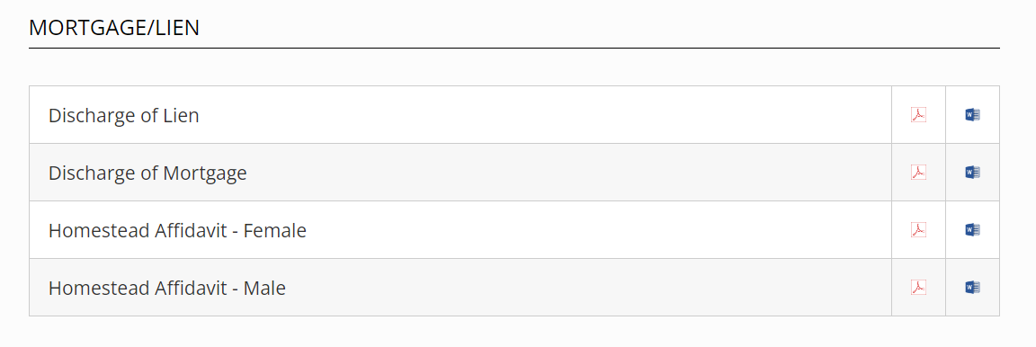
Copyright ©2023 MS Title Agency, All Rights Reserved.

